8th Grade Elective Class Descriptions

Arts, Visual Arts, Performing Arts, Music, Dance:
Art Foundations 1
Art Foundations is an introductory studio art class that explores art mediums and techniques. Art Foundations teaches basic techniques including drawing, perspective, ceramics, painting, graphic design, and more. Students will expand their creative voice through practicing, planning, and creating art projects. Art Foundations is a studio class focusing on making art projects versus just learning about art theory. $
Art Foundations 2
This course builds on Art Foundations 1 and explores art mediums and techniques. It teaches basic techniques including drawing, perspective, painting, graphic design, and more. Students will expand their creative voice through practicing, planning and creating art projects. [Prerequisite: Art Foundations 1] $
Art Foundations 3
This course builds on Art Foundations 2 students will continue to develop their skills with a variety of mediums such as watercolor, graphite, & various 3D materials. Students will continue to expand their creative voice through practicing, planning, & creating a variety of artworks. [Prerequisite: Art Found 1 & 2] $
Ceramics 1
This beginning ceramic class is designed for students who have an interest in working with clay and will give students experiences in making functional and sculptural pieces. Everything in this class is hand built using a variety of ceramic techniques. $
Ceramics 2
This ceramic class is designed for students who want to learn advanced hand building skills and learn the basics of making functional pottery on a potter’s wheel. Ceramics I is required BEFORE you can take Ceramics 2. [Prerequisite: Ceramics 1] $
Ceramics 3
This ceramic class is designed for students who want to keep learning advanced hand building skills & learn the basics of making functional pottery on a potter’s wheel. [Prerequisite: Ceramics 1&2] $
Theatre 2
This class improves student’s acting skills with more in-depth projects. Script writing and play creation will become a major focus in Theatre 2. Students will begin to present their own work to the community and school. The class will culminate in a student written performance with opportunities for students to explore more roles within theatre beyond acting (directing, designing, writing, etc.). $
Theatre 3
This class gives students the chance to explore and analyze various forms of theatre in more depth. Including theatre history, film, global theatre, acting styles, and creating /devising original theatre. [Prerequisite - Theatre 1 and/or Theatre 2] $
Advanced Theatre
This course emphasizes advanced acting skills and techniques for stage & film as well as competitive acting techniques. Live performance commitments continually throughout the duration of the course. [Audition based] $
Technical Theatre
Students will explore all major areas of theatre design and production, including props, costumes, hair, makeup, lighting, sound, and backstage management. Students in this course are expected to design and run the live performances throughout the school year. $ [Application in auditorium]
Concert Choir
Join the super awesome amazing Concert Choir!! Concert Choir is an advanced choir class for 7th and 8th graders where we focus on vocal production and part-singing in preparation for high school performing groups. Concert Choir performs in school assemblies, concerts, & around the community too. Rehearsals & performances outside of class time are a significant part of the course and are graded. Teacher signature is required. $
Treble Makers Show Choir
Do you like to sing AND dance?? Here is your chance!! Come join the Treble Makers!! Come learn to sing amazing arrangements of popular songs you know and love with the added bonus of choreography and costumes!! Rehearsals and performances outside of class time are a part of the course and are graded. $
Music Crash Course
Interested in music but don’t want to perform? This hands-on project-based course is for students who want to learn more about music outside of a performing group class. In this course you will be listening, analyzing, composing & improvising music as well as playing instruments & singing. Music history, world music appreciation and the history of rock and roll will all be discussed and briefly explored. $
Beginning Band
This is a course in beginning band offered for students who have had little or no previous experience in playing an instrument. $
Concert Band
This intermediate-level band course encourages increased technical & expressive musical proficiency through performance & the study of music. Rehearsals & performances outside of class time are part of the course requirement & constitute a portion of the grade. $
Guitar
7th and 8th Graders!! Do you want to learn how to shred like your favorite rock musician? Do you want to be the campfire song guru? Take the guitar class!! An acoustic guitar is required to participate in the class. $
Beginning Orchestra
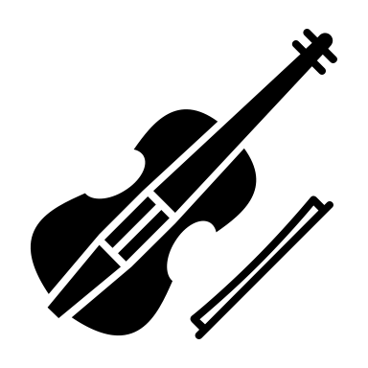
Beginning Orchestra is for anyone interested in playing the violin, viola, cello or string bass in a group setting. $
Intermediate Orchestra
Intermediate Orchestra is for anyone who has played the violin, viola, cello or string bass for one or more years. $
Advanced Orchestra
This is an audition class meant for students who have excelled in Beginning and/or Intermediate Orchestra, or have had at least 1 year of private lessons, or have surpassed expectations in their elementary orchestra. Signature is required from our orchestra teacher, Mrs. Palmatier (nicole.palmatier@canyonsdistrict.org) for an audition. $
Career and Technical Education:
FACS A
Students will explore and cultivate skills in interior design, clothing & textile construction, fashion design and merchandising, consumerism, entrepreneurship and career and job-related tasks. $
FACS B
Students will explore and cultivate skills in food and nutrition, childcare, consumerism, entrepreneurship, family relationships, personal responsibility, and career and job-related tasks. $
Bobcat Market
Students will be exposed to the fundamental concepts of business and marketing, through project-based learning. The projects will include running the school PBIS store and creating marketing campaigns for school-wide events. A variety of skills will be practiced which include basic business concepts, organizational communication, human resources management, entrepreneurship, accounting, finance, and leadership. $ [Ms. Fillmore’s signature required]
Digital Literacy
This course is an introduction to computer literacy. Student will have opportunities to use technology and develop skills that encourage creativity, critical thinking, productivity, and collaboration in the classroom and day-to-day life. Skills will be demonstrated by creating a project for a different content area. This course is aligned with national and international standards and the Utah Core to prepare students across multiple levels of skills.
Healthy Lifestyles:
Team Sports
This is an advanced PE class designed to focus on activities that involve group participation such as basketball, volleyball, football, & soccer. $
Strength & Conditioning
Basic weightlifting principles and techniques along with basic muscular anatomy, and a variety of workouts that will help improve the 5 components of fitness: muscular strength, muscular endurance, cardiovascular endurance, flexibility, and body composition. $
Dance 2 (Technique)
This class utilizes the elements of dance to improve dance technique and improve the dancer’s skill in the improvisation & composition. [Prerequisite: Dance 1, or 2 yrs. Dance Experience] $
Dance 3 (Composition)
This class utilizes the basic elements of dance as we explore the creation of movement and the choreographic process. Emphasis is placed on honing choreographic and performance techniques. [Prerequisite: Dance 1 or 2 & Signature from Ms. Paulsen] $
Dance Company
This is an auditioned based class. Advanced level technique and choreographic skills required. Emphasis is placed on producing and refining choreography for performances. Rehearsals & performances outside of class are required and constitute a portion of the grade. [Prerequisite: Dance 1, 2, or 3 & Instructors approval} $
Social Dance
This class is an exploration of various social dance forms such as folk dance, line dances, and fundamental steps of the ballroom dances. Students learn how dance can have an impact on social interactions. $
Other School Options:
Peer Tutor
We are looking for responsible students who would like to be a positive influence on our special education students. If you would like to help assist these students and have a rewarding class period, this is for you.
Office Aide & Teacher Aide
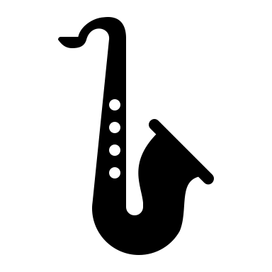
We are looking for responsible students who would like to assist teachers and/or the attendance office.
$ = | There will be a class fee for this class
= | Instrument Rental Required- some school rentals available
= | Application Process Required

